

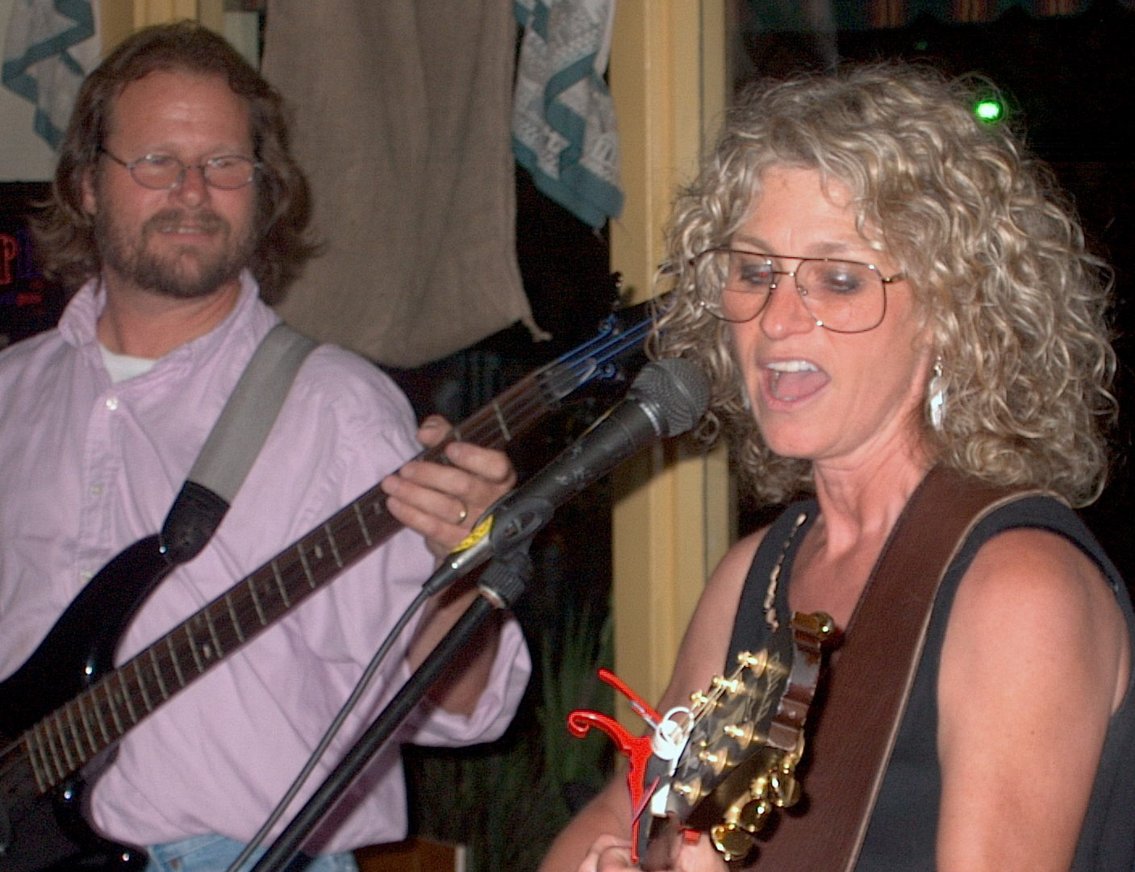

PATTY HALL LIVE!

THE NORTH PARK VAUDEVILLE SHOW

NORTH PARK VAUDEVILLE & CANDY SHOPPE THEATER

2031 El Cajon Blvd.

San Diego CA

Saturday, SEPTEMBER 18, 2004 *** 8 PM

Sunday, SEPTEMBER 19, 2004 *** 2 PM

Patty will showcase some of her sassiest NATIVE DAUGHTER™ and JUMPIN' UP™ SONGS at this family-friendly variety show. Join her, and 8 other acts, for a memorable event re-capturing the fine old days of vaudeville. Admission $11. in advance, $13. at the door. Children $6. Credit cards accepted. FOR INFO and RESERVATIONS call: (619) 647-4958. Presented by GB Productions.

VISIT PATTY on the Web at www.pattyhall.com

